Create Vector Index & Ingestion Pipeline

Option A — Portal-first approach, recommended for you now

Use the Azure AI Search or Foundry “import and vectorize” workflow.

High-level steps:

Open Azure AI Search.
  - Login to Azure Portal.
  - Enter Azure AI Search in Azure Portal Search bar and select AI Search (Foundry IQ).
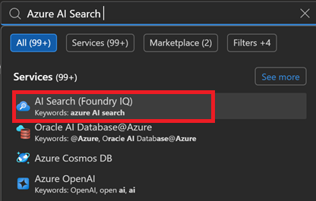

Select your search service.
  - Select Azure AI Search resource.
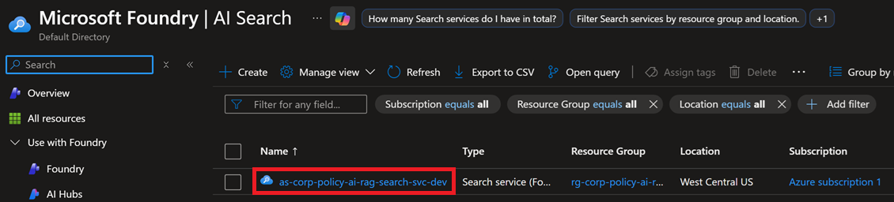

Choose Import and vectorize data.
  - Select Import data to select data source.
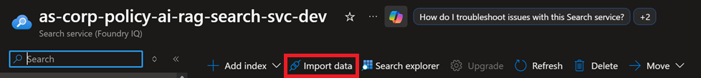

Select Azure Blob Storage as the data source.
  - Click Azure Blob Storage option.
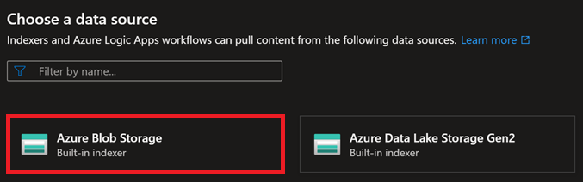

Select and configure RAG Solution Scenario.
  - Select RAG solution scenario.
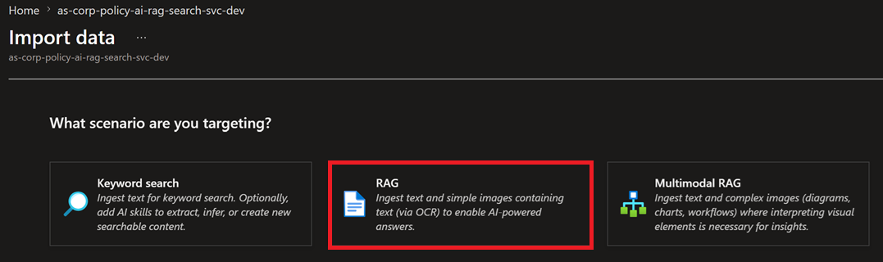

Configure Azure Blob Storage
  - Enable the following RAG settings:
    - Select Subscription.
    - Select Storage Account.
    - Select Blob container.
    - Select Parsing mode.
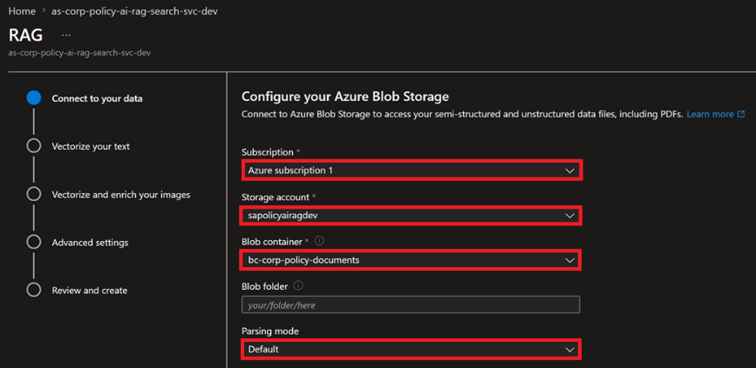
  - Enable the following RAG settings:
    - Select Enable deletion tracking.
    - Select Native blob soft delete.
    - Select Authenticate using managed identity.
    - Select System-assigned.
    - Click Next button.
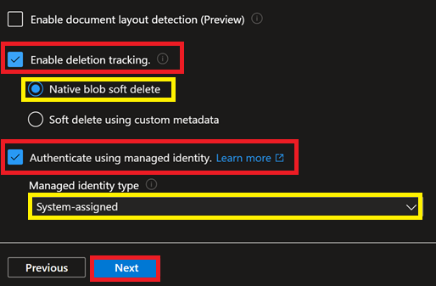

Vectorize text.
  - Select the following Vectorize Text settings:
    - Select resource Kind.
    - Select cloud/Azure Subscription.
    - Select the Micro.soft Foundry service/project containing your embedding.
    - Select your Embedding Model deployment.
    - Select your Authentication type.
    - Select I acknowledge that connection a Microsoft Foundry resource will incur additional cost t my account.
    - Click Next button.
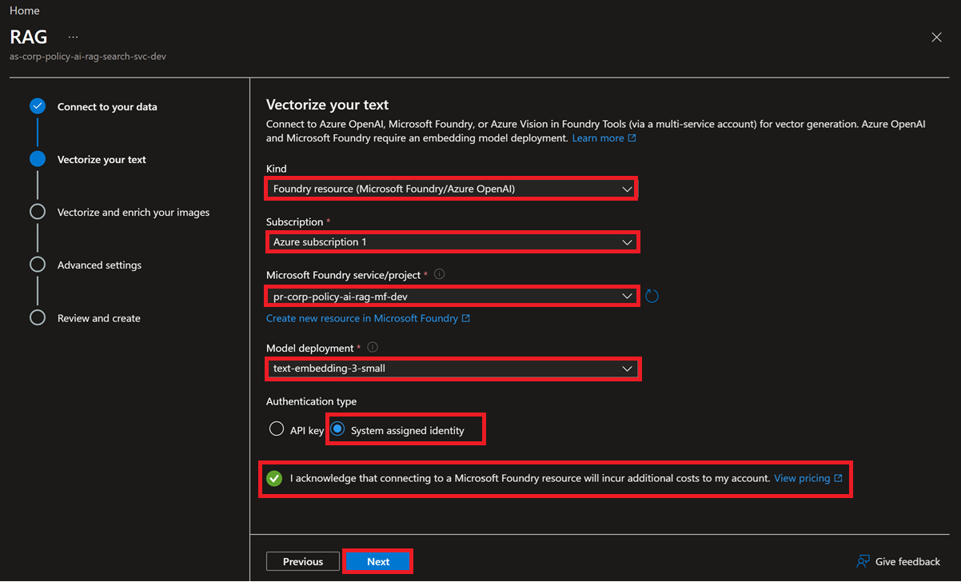

Vectorize and enrich images.
  - Vectorize images and Extract text form images unchecked. Click Next button.
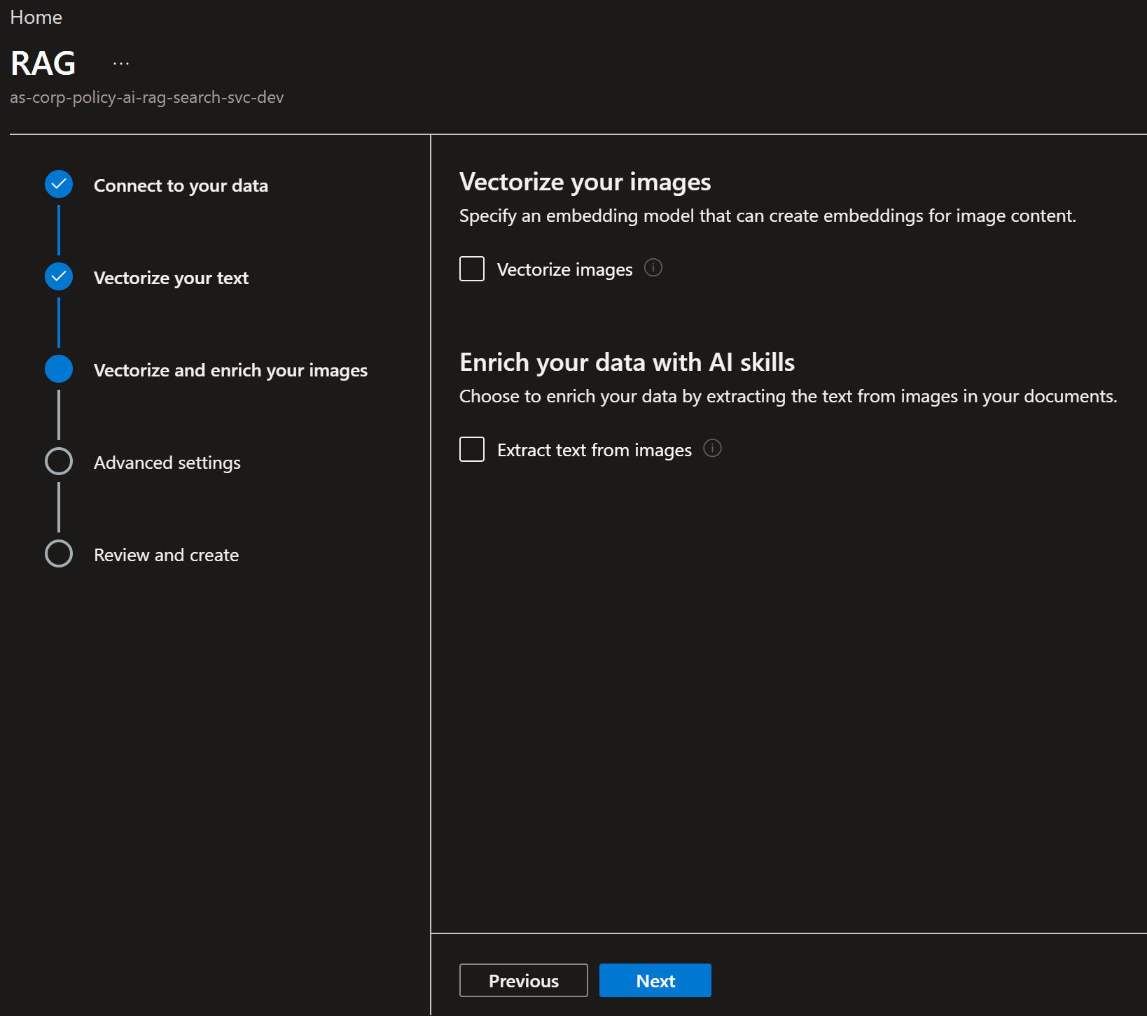

Enable Advanced ranking, preview index fields, and schedule indexing.
  - Click Enable semantic ranker and select ScheduleDaily. Click Next button.
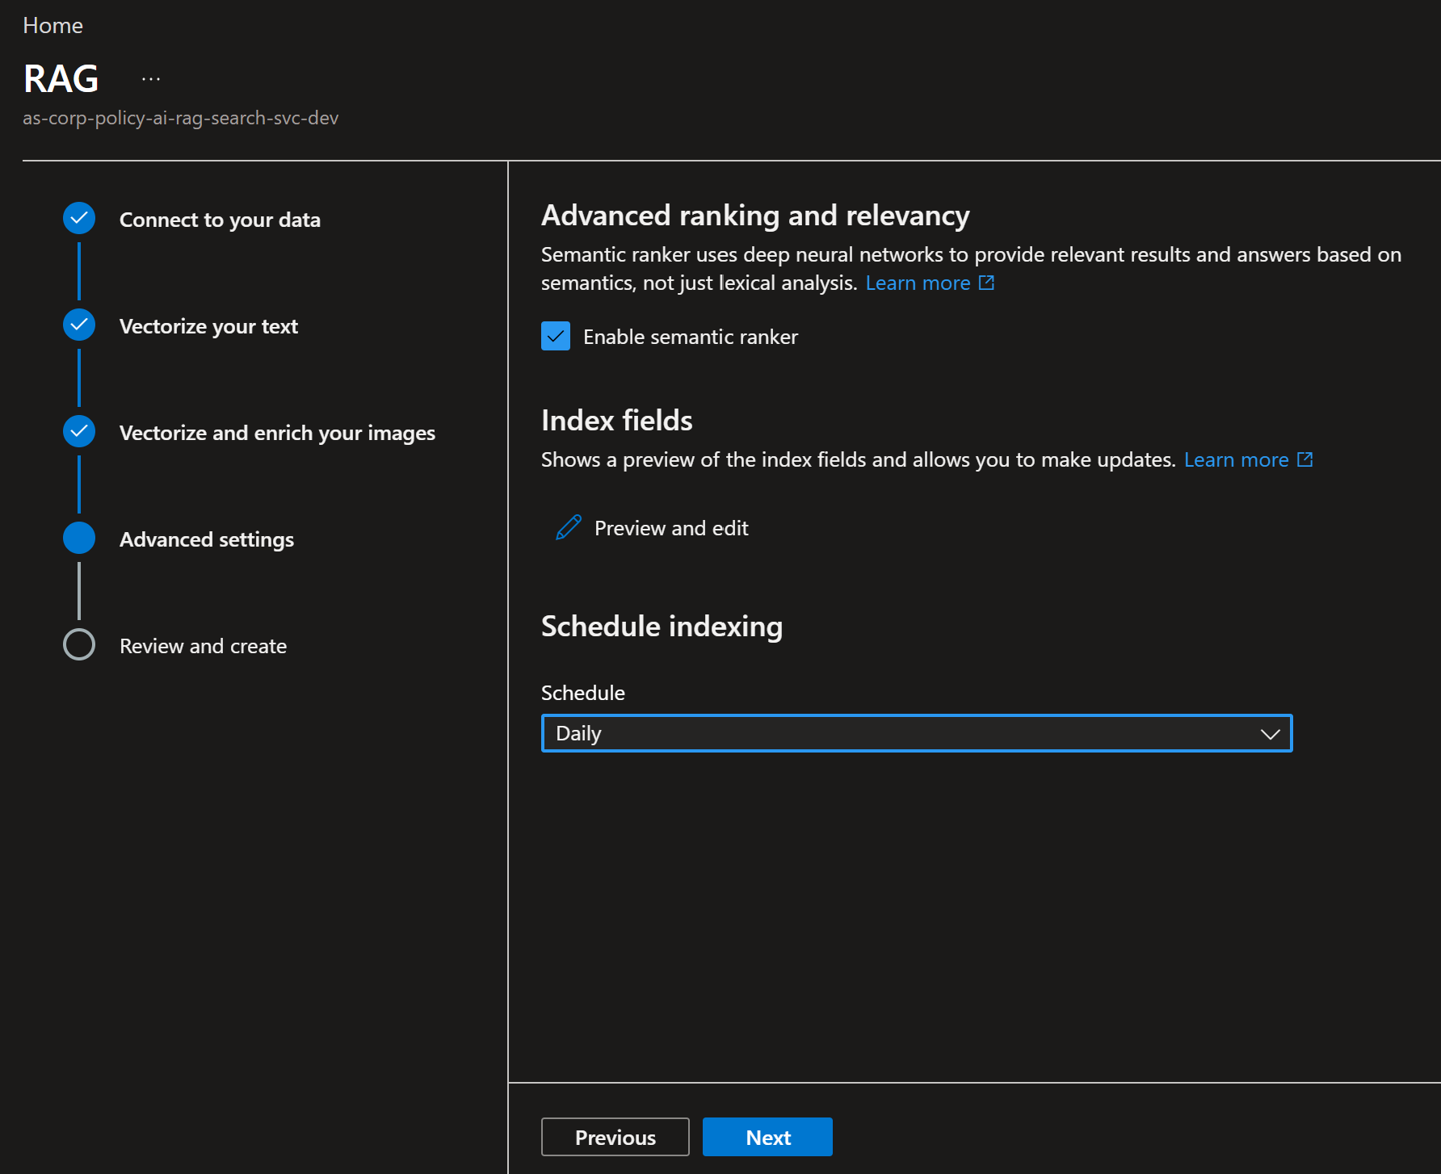

Create Vector Index.
  - Click Create button to create the Vector Index.
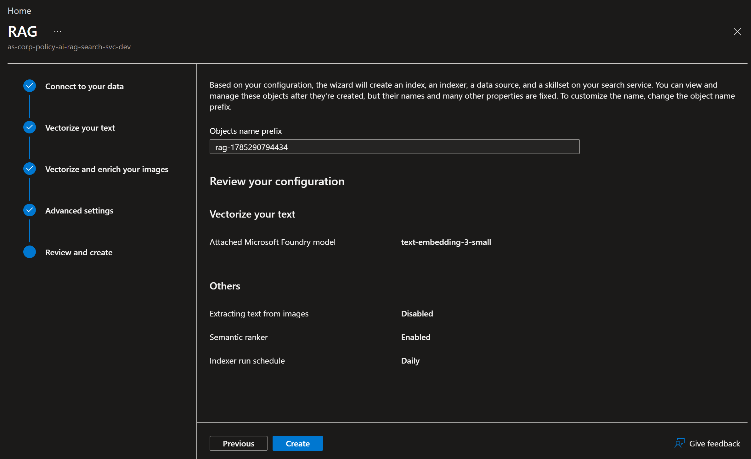

Select your policy-documents container.

Choose your embedding model deployment.

Let the wizard create:

Data source

Skillset

Index

Indexer

Vector field

Chunking configuration

Run the indexer.

